**Name: Nidhi Pednekar**

**Class: D15B / 47**

**ADV DEVOPS PRAC 2**

**Aim:** To Build Your Application using AWS CodeBuild and Deploy on S3 / SEBS using AWS CodePipeline, deploy Sample Application on EC2 instance using AWS CodeDeploy.

**Theory:**

Continuous deployment allows you to deploy revisions to a production environment automatically without explicit approval from a developer, making the entire software release process automated. You will create the pipeline using AWS CodePipeline, a service that builds, tests, and deploys your code every time there is a code change. You will use your GitHub account, an Amazon Simple Storage Service (S3) bucket, or an AWS CodeCommit repository as the source location for the sample app’s code. You will also use AWS Elastic Beanstalk as the deployment target for the sample app. Your completed pipeline will be able to detect changes made to the source repository containing the sample app and then automatically update your live sample app.

**Step 1) Role Creation:-**

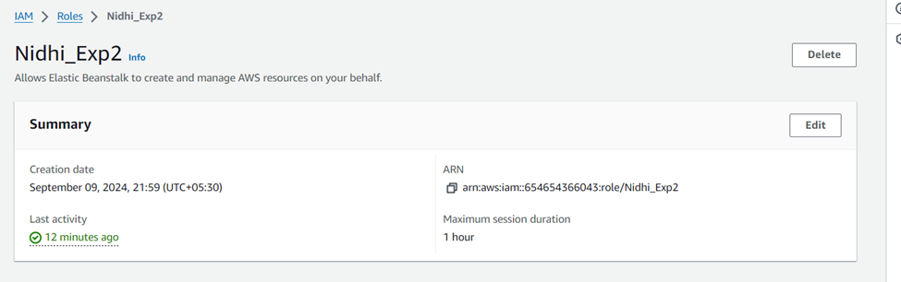

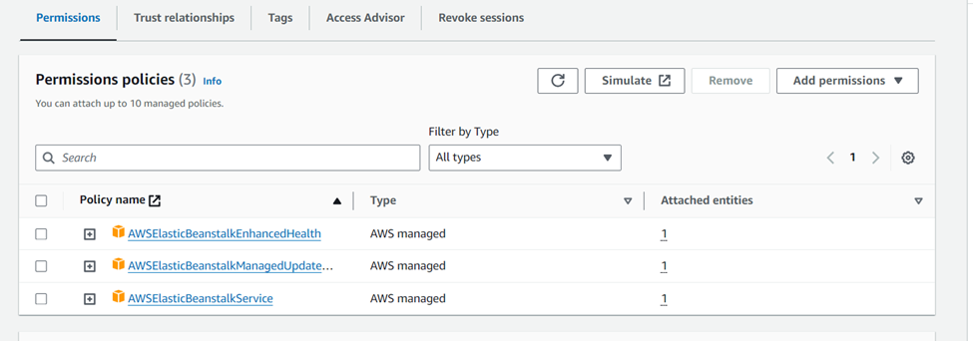

**Step 2) Environment Creation:-**

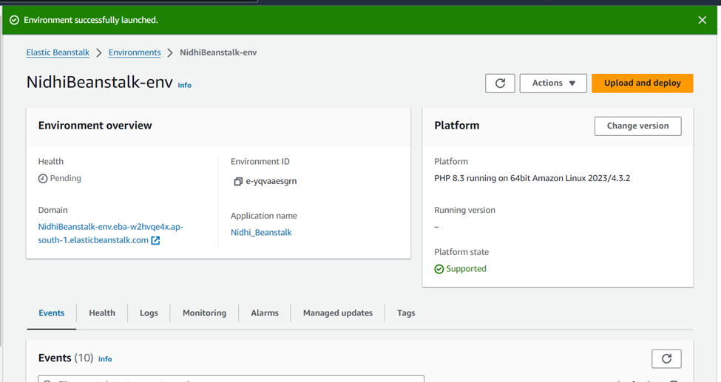

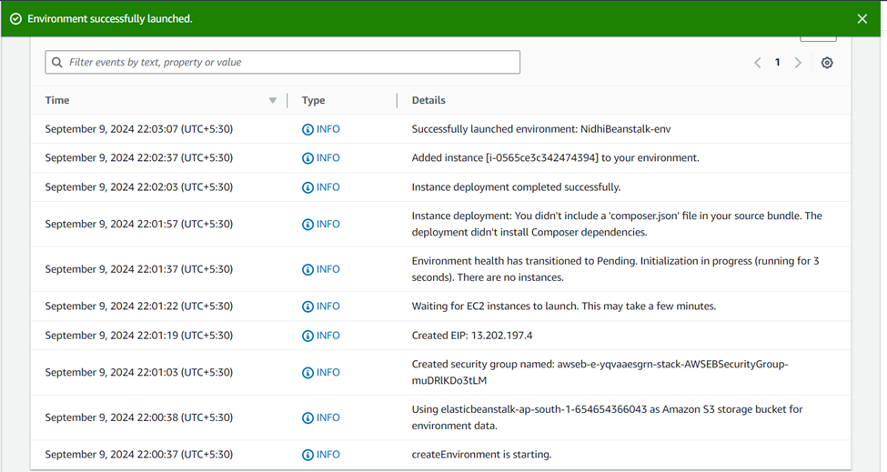

**Step 3) Pipeline Creation:-**

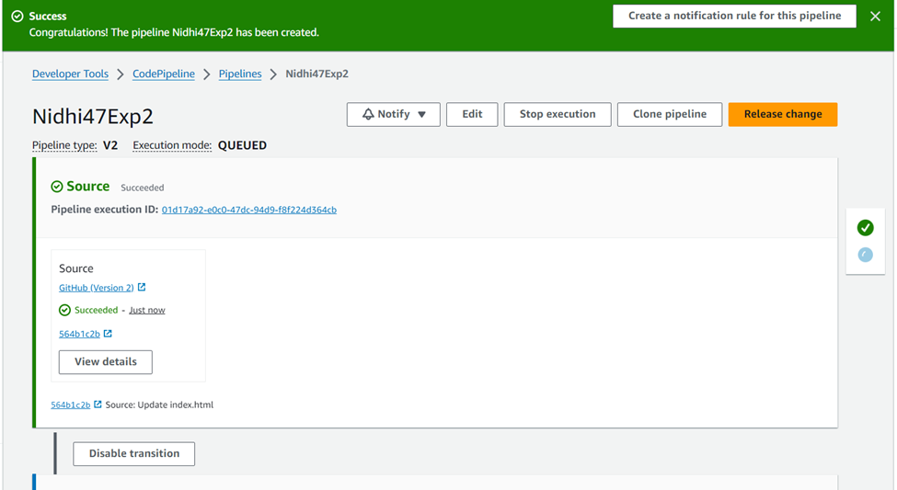

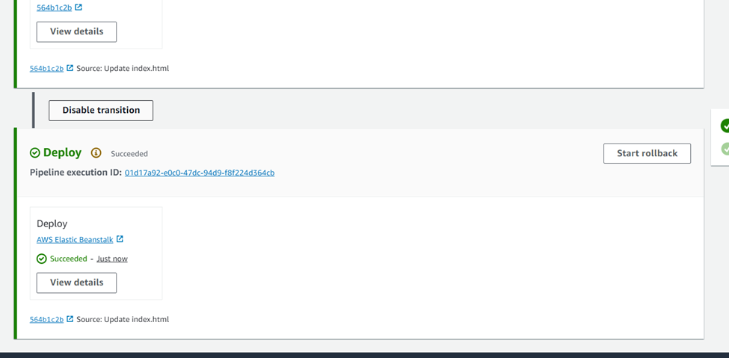

**Step 4) Before Updating:-**

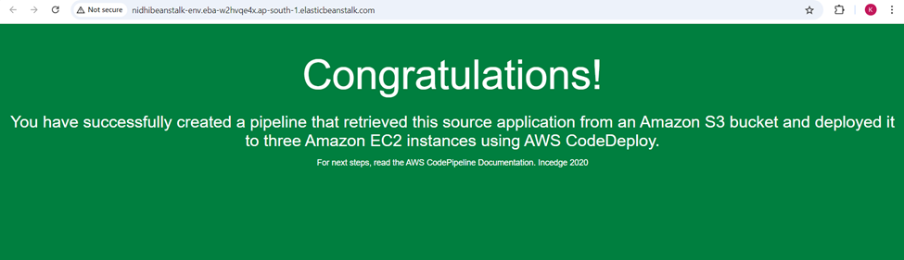

**Step 5) After Updating:-**

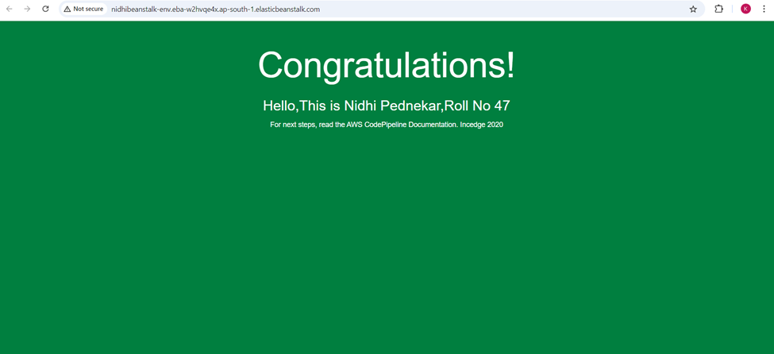

**Conclusion:** Continuous deployment automates the software release process by deploying revisions to production without manual intervention. Using AWS CodePipeline, you can build, test, and deploy code automatically whenever changes are detected. This process integrates with a source repository like GitHub, S3, or CodeCommit and uses AWS services like CodeBuild for compiling, CodeDeploy for managing releases, and Elastic Beanstalk or EC2 for deploying applications. With this setup, any code change in the source repository will trigger an automated pipeline, ensuring that the live application stays up-to-date without requiring explicit developer approval.